Year 8 Science EXAM REVISION

***Complete the following questions in your notebooks, using your notes and textbooks***

1. **Explain** how a mineral is different from a rock?

|  |
| --- |
|  |

1. **Define** the following terms relating to minerals, and give an example where possible:

|  |  |
| --- | --- |
| 1. Lustre |  |
| 1. Streak |  |
| 1. Cleavage |  |
| 1. Hardness |  |
| 1. Density |  |
| 1. Colour |  |

1. **Explain** the difference between magma and lava.

|  |
| --- |
|  |
|  |

1. **Identify** which type of rock (igneous, sedimentary or metamorphic) is being described by each statement below:

|  |  |
| --- | --- |
| 1. has layers |  |
| 1. has pebbles all cemented together |  |
| 1. Has wavy uneven layers |  |
| 1. has crystals which interlock with each other |  |
| 1. formed by cooling molten magma |  |
| 1. formed by changing existing rocks with heat and pressure |  |
| 1. may contain fossils |  |
| 1. formed from lava |  |
| 1. This rock is formed from weathering, erosion, deposition, compaction, and cementation |  |
| 1. There are two main types of this rock – contact and regional. |  |
| 1. Formed from magma. |  |
| 1. Granite and pumice are examples of this type of rock |  |
| 1. Marble and gneiss are examples of this type of rock |  |
| 1. Sandstone and conglomerate are examples of this type of rock. |  |

1. **Identify** the igneous, metamorphic and sedimentary rock below:

|  |  |  |
| --- | --- | --- |
|  |  |  |
|  |  | Experiment with Pumice – Experiment Exchange |

1. **Explain** the difference between an intrusive and an extrusive igneous rock in terms of
2. How they are formed

|  |
| --- |
|  |
|  |

1. Their appearance – the size of the crystals

|  |
| --- |
|  |
|  |

1. **a)** **Explain** what a fossil is.

|  |
| --- |
|  |
|  |

**b)**  **Describe** how fossils are formed.

|  |
| --- |
|  |
|  |

**c) Explain** why fossils are useful to science.

|  |
| --- |
|  |
|  |

1. **Summarise** the main characteristics of the three types of rocks by completing the table:

|  |  |  |  |
| --- | --- | --- | --- |
| **TYPE OF ROCK** | **HOW are they formed?** | **WHAT do they commonly look like?** | **Names of some EXAMPLES** |
| Igneous |  |  |  |
| Sedimentary |  |  |  |
| Metamorphic |  |  |  |

1. **Explain** which type(s) of rock you would expect to find fossils in, and which type(s) you would not expect to find fossils in.

|  |
| --- |
|  |
|  |
|  |
|  |

1. **Explain** how each of the following processes contribute to making sedimentary rock:

weathering, erosion, compaction, cementation.

|  |
| --- |
|  |
|  |
|  |
|  |
|  |

1. **Complete** the diagram of the rock cycle below:

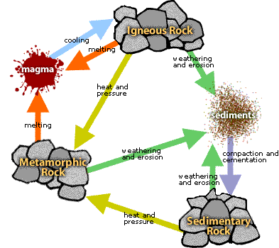

1. Use the diagram to **explain** how the rock cycle is NOT a one-way process:

|  |
| --- |
|  |
|  |
|  |

1. The following questions refer to this rock face:

**J**

**R**

**H**

**P**

**D**

**I**

1. **List** the rock types from oldest to youngest:

|  |
| --- |
|  |

1. **Identify** which layer is the most resistant to weathering.

|  |
| --- |
|  |

1. **Explain** how you know for (b)

|  |
| --- |
|  |
|  |

1. **Identify** which type of rocks would take the longest to form, and **explain** why.

|  |
| --- |
|  |
|  |
|  |

1. **Predict** which would have the greatest pressure, and **explain** why – a finger pressed into the palm of your hand, or a pin pushed into the palm of your hand – both with the same amount of force.

|  |
| --- |
|  |
|  |

1. **Classify** the following rocks as either Igneous, Sedimentary or Metamorphic:
2. Shale _______________ e) Basalt _________________
3. Granite _______________ f) Conglomerate _________________
4. Mudstone _______________ g) Pumice _________________
5. Marble _______________ h) Slate _________________
6. **Use** the information below to identify the difference between mudstone and sandstone:

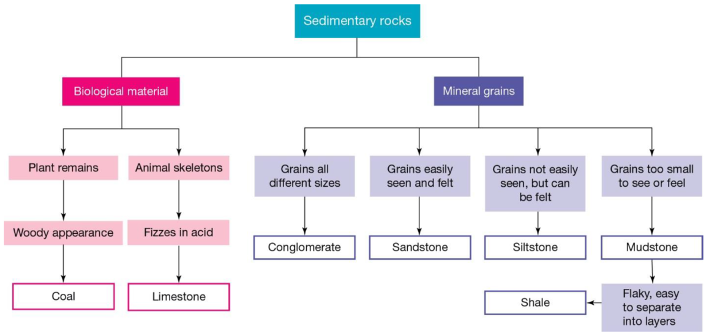

|  |
| --- |
|  |
|  |

1. **Summarise** the importance of the mining rehabilitation process.

|  |
| --- |
|  |
|  |
|  |

1. **Use** the table below to answer the questions.

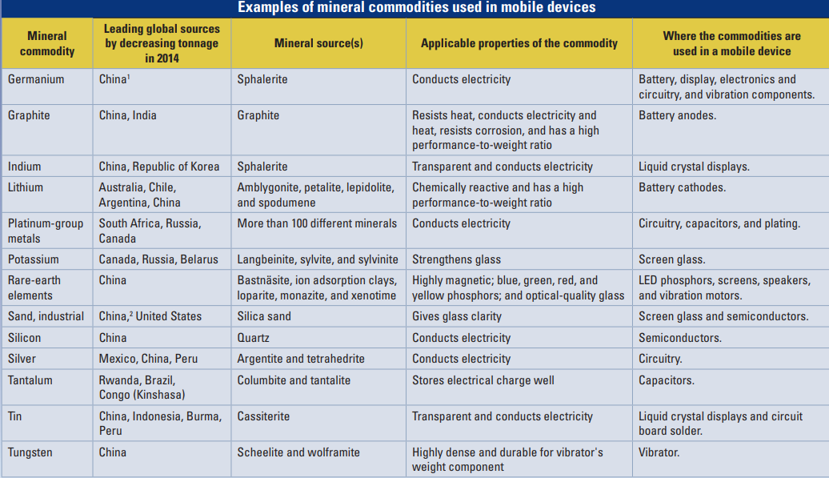

1. **Identify** from the table, a mineral that is mined in Mexico that is used in mobile phones

|  |
| --- |
|  |

1. **Identify** the 2 minerals that are used in screen glass in mobile phones.

|  |
| --- |
|  |
|  |

1. Using the properties of the minerals identified in question 20, **explain** why they have been chosen for use in screen glass.

|  |
| --- |
|  |
|  |